CPSC 3300 – Homework 3

Due 11:59PM Tuesday, March 9

Submit your answers to Canvas

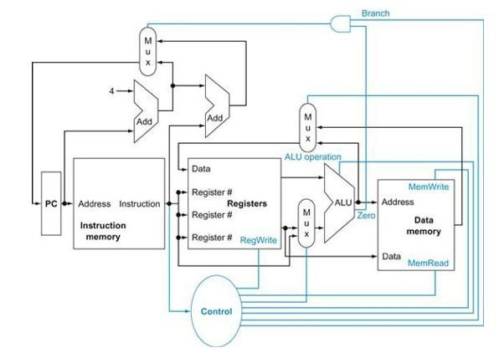

❶

❷

❸

1. Consider the MIPS “load word” instruction as implemented on the datapath above (Figure 4. from textbook):

lw R2, 8(R1) // Reg[2] <- memory[ Reg[1] + 8 ]

Circle the correct value 0 or 1 for the control signals (a-d) and circle whether each of the three muxes (e-g) selects its upper input, lower input, or don't care. For the ALU operation (h) circle one of the function names. (The Zero condition signal will be assumed to be 0.) (20 pts.)

* 1. Branch = 0 1 (e) Mux1 (upper left; output to PC) = upper, lower, don't care
  2. MemRead = 0 1 (f) Mux2 (upper middle; output to Data port of Regs) = upper, lower, don't care
  3. MemWrite = 0 1 (g) Mux3 (lower middle; output to bottom leg of ALU) = upper, lower, don't care
  4. RegWrite = 0 1 (h) ALU operation = and, or, add, subtract, set-on-less-than, nor

1. Consider the MIPS “store word” instruction as implemented on the datapath above (Figure 4.2 from textbook):

sw R4, -12(R3) // Memory[ Reg[3] + signextended(-12) ] <- Reg[4]

Circle the correct value 0 or 1 for the control signals (a-d) and circle whether each of the three muxes (e-g) selects its upper input, lower input, or don't care. For the ALU operation (h) circle one of the function names. (The Zero condition signal will be assumed to be 0.) (20 pts.)

* 1. Branch = 0 1 (e) Mux1 (upper left; output to PC) = upper, lower, don't care
  2. MemRead = 0 1 (f) Mux2 (upper middle; output to Data port of Regs) = upper, lower, don't care
  3. MemWrite = 0 1 (g) Mux3 (lower middle; output to bottom leg of ALU) = upper, lower, don't care
  4. RegWrite = 0 1 (h) ALU operation = and, or, add, subtract, set-on-less-than, nor

1. For the MIPS instruction sequence below, complete the data dependency diagram. (Destination register is listed first except for sw instruction; sw writes into memory rather than a register.) (15 pts.)

i1: lw r4, 0( r1 ) // reg[4] ← memory[ reg[1] + 0 ] i2: lw r5, 4( r1 ) // reg[5] ← memory[ reg[1] + 4 ] i3: mul r6, r4, r5 // reg[6] ← reg[4] \* reg[5]

i4: sub r8, r6, r7 // reg[8] ← reg[6] - reg[7]

i5: sw r8, 8( r1 ) // memory[ reg[1] + 8 ] ← reg[8] i6: add r1, r1, r2 // reg[1] ← reg[1] + reg[2]

r1 r1



i1: lw

i2: lw

r4/RAW

r5/RAW

i3: mul

r1/RAW

i6: add

r6/RAW

i4: sub

i5: sw

r8/RAW

1. Draw the dependency diagram for the following MIPS code (15 pts.)

i1: add r3, r1, r2 // reg[3] ← reg[1] + reg[2]

i2: lw r5, 0(r3) // reg[5] ← memory[ reg[3] + 0 ]

i3: add r3, r3, r6 // reg[3] ← reg[3] + reg[6]

i4: addi r5, r5, 1 // reg[5] ← reg[5] + 1

i5: sw r5, 0( r3 ) // memory[ reg[3] + 0 ] ← reg[5]

r2

r1

r3/RAW

r3/RAW

r5/RAW

i5: sw

r5/RAW

i4: addi

r2

r3/RAW

i3: add

i2: lw

i1: add

1. For the following MIPS instruction sequence, complete the pipeline cycle diagram for the standard 5- stage pipeline without forwarding. Assume register file writes occur in the first half cycle and reads in the second half cycle. (15 pts.)

i1: lw r1, 0( r5 ) // reg[1] ← memory[ reg[5] + 0 ]

i2: add r3, r1, r2 // reg[3] ← reg[1] + reg[2]

i3: addi r4, r3, 1 // reg[4] ← reg[3] + 1

i1:lw IF ID EX MEM WB

EX MEM WB

i2:add IF ID

IF ID EX MEM WB

i3:addi

1. For the following MIPS instruction sequence, complete the pipeline cycle diagram for the standard 5- stage pipeline with forwarding. Assume register file writes occur in the first half cycle and reads in the second half cycle. (15 pts.)

i1: lw r1, 0( r5 ) // reg[1] ← memory[ reg[5] + 0 ]

i2: add r3, r1, r2 // reg[3] ← reg[1] + reg[2]

i3: addi r4, r3, 1 // reg[4] ← reg[3] + 1

i1:lw IF ID EX MEM WB

ID EX MEM WB

i2:add IF

IF ID EX MEM WB

i3:addi